CIDG GRADE guidance
Prepared by: Paul Hine (CIDG Research Assistant), with input from Samuel Johnson (CIDG Research Associate) and Paul Garner (CIDG Co-ordinating Editor)
Date: 15 August 2018
Different review authors have adopted different approaches to incorporate GRADE into Cochrane Reviews. The Cochrane Handbook for Systematic Reviews of Interventions¹ and Cochrane MECIR guidance² suggests that judgements should be described in the ‘Results’ or ‘Discussion’ section of the review, or both, or as part of the ‘Summary of findings’ table. For consistency across CIDG reviews, we recommend the following approach:
Review text | Review authors should refer to ‘certainty’ rather than ‘quality’ of evidence when referring to GRADE ratings throughout the review text.
Methods | Review authors should add a level 3 subheading: ‘Certainty of the evidence’ under ‘Data synthesis’. Within this section, the authors should give a simple description of GRADE. Further details should be given in the ‘Discussion’ section.
Results | Do not cite ‘Summary of findings’ tables in the ‘Results’ section of the review.  Review authors should not include GRADE ratings within ‘Results’. Authors should present: RR, 95% CI, number of participants, number of trials, and a link to the analysis. For example: (RR 1.27, 95% CI 1.12 to 1.28; 3 trials, 300 participants, 3 trials, Analysis 2.4).
Discussion | Review authors should cite and hyperlink the ‘Summary of findings’ table(s) at the start of the ‘Discussion’ section.  Authors should include GRADE ratings within the ‘Summary of main results’, and use standard language to describe them. The estimate of effect is not compulsory here. For example:  For Outcome A, drug A may reduce deaths compared drug B (low-certainty evidence)  Authors should de-activate the subheading ‘Quality of evidence’, and introduce a subheading ‘Certainty of the evidence’. Within this section, the review authors should summarize key considerations relevant to GRADE.

‘Summary of findings’ table | The ‘Summary of findings’ table should present GRADE assessments as follows:  Outcome Anticipated absolute effects (95% CI) Relative effect (95% CI) Number of participants (studies) Certainty of the evidence (GRADE) Comments  Risk with A Risk with B  Death 5 per 1000 7 per 1000 (3 to 15) RR 1.24 (0.54 to 2.84) 3941 (7 RCTs) ⊕⊕⊕⊝ MODERATEª Due to imprecision B probably makes little or no difference to death compared to A.  Column 5 ‘Certainty of the evidence (GRADE)’ should include the GRADE, and a description of the reasons for downgrading. There should be a footnote to explain this decision in greater depth. The structure of the footnote should be as follows:  ‘Downgraded by 1 for serious imprecision: the confidence interval includes both no effect and clinically significant effect.’  ‘Downgraded by 2 for very serious risk of bias: all studies at serious risk of bias.’  Column 6 ‘Comments’ should explain in plain language the authors’ interpretation. Where possible this should use standard terminology provided by Cochrane Norway³, however the review authors may need to adapt this depending on the nature of the review.
Abstract | The abstract should include a simple description of the findings, and: RR, 95% CI, number of participants, number of trials, and GRADE. For example, (RR 0.59, 95% confidence interval (CI) 0.26 to 1.31; 4 RCTs, 3068 participants, low-certainty evidence)
Plain language summary | This should include the plain language description of the authors’ interpretation using GRADE.

Extract from Cochrane Norway guidance³:
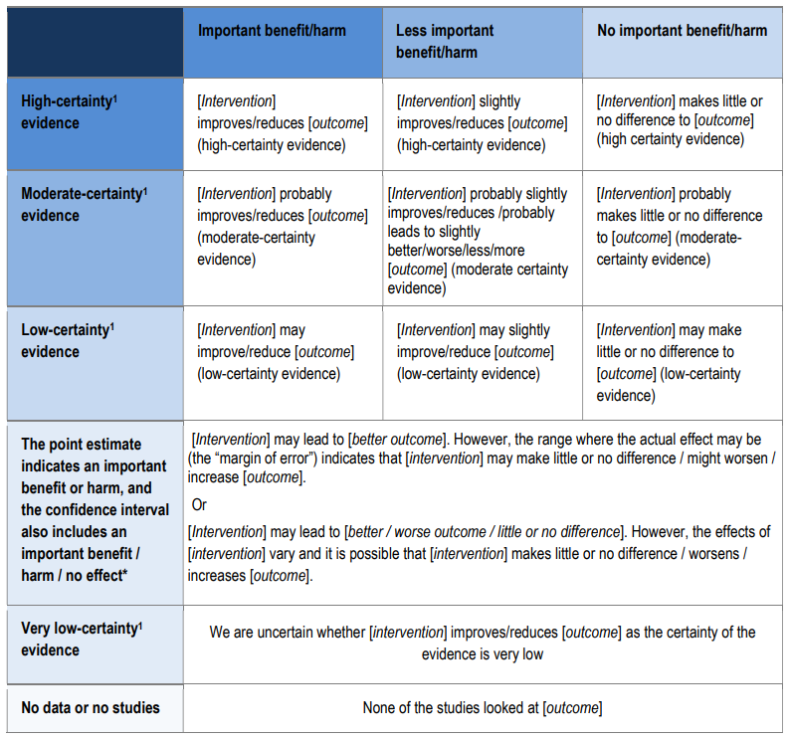
¹Schünemann HJ, Oxman AD, Higgins JPT, Vist GE, Glasziou P. Guyatt GH. Chapter 11: Presenting results and ‘Summary of findings’ tables. In: Higgins JP, Green S, editor(s). Cochrane Handbook for Systematic Reviews of Interventions Version 5.1.0 (updated March 2011). The Cochrane Collaboration, 2011. Available from handbook.cochrane.org.
²Higgins J, Lasserson T, Chandler J, Tovey D, Churchill R (2018) Standards for the conduct and reporting of new Cochrane Intervention Reviews, reporting of protocols and the planning, conduct and reporting of updates. R98. Version 1.05. Last update January 2018. Available at: https://community.cochrane.org/mecir-manual
³Cochrane Norway. How to write a plain language summary of a Cochrane intervention review. Checklist 23 May 2016. https://www.cochrane.no/sites/cochrane.no/files/public/uploads/checking_a_cochrane_pls_15th_june_2018.pdf

